Mr. Gorham Name: ___________________________
Modern American History-Honors Block: ______
Cold War/1950s

Sex, Dating, and Marriage in the Fifties (HW 20 pts.)
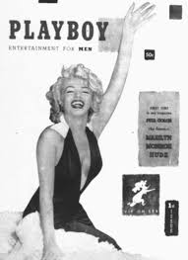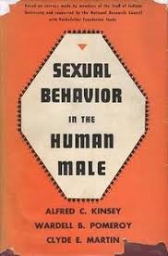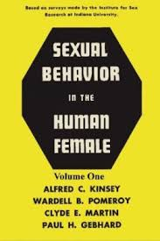
Dating Rituals. By the end of the 1950s, more than 14 million girls were married by the age of 17! Stages of romantic relationships: Hang out on playground when young -> flirt & talk -> date (start with double dating/blind dates/set-ups and move on to single dating -> going steady -> marriage.
Changes over time in the meaning of “dating” – before the war, going steady meant that you were headed towards marriage. After the war, the term “going steady” was used more loosely and instead had come to mean you were dating exclusively but it was not guaranteed that they had serious thoughts of marriage.
The Kinsey Report.
Using your computer and your wits, who was Alfred Kinsey and what was the “Kinsey Report”?

The Birth Control Pill. Margaret Sanger initially conceived the idea for the birth control pill (as a form of population control for the poor.) Within 2 years of FDA approval of the pill, 1.2 million women were taking it. Within 5 years of FDA approval, over 6 million women were taking it. By 1964, the pill had become the most popular form of contraception in the country, used by 1⁄4 of all couples using contraception.
What do you think was the impact of the pill had on sexual practices and the birth-rate?

What was the “Baby Boom” and who are the “Baby Boomers”?

Marilyn Monroe, Hugh Hefner and Playboy. Marilyn Monroe was made famous by appearance on the first Playboy cover. “We lived in what I then and now viewed as a very repressive, sick society... And then when I was in college the first Kinsey report came out in 1948, and it was a revelation for me, because it confirmed the hypocrisy for me, the gap between what we said and what we actually did.” The founder of Playboy, a “men’s magazine,” Hugh Hefner had a goal: he wanted a more open discussion of sex, believed sexuality could be viewed as sophisticated. The message to the American public was sex is natural & should be embraced – don’t be embarrassed, male sexual fantasies are normal. Don’t deny pleasure, pleasure is natural. The target audience was middle-class Americans. Playboy was part of a larger, more sophisticated post-war lifestyle – advice on buying, ordering, wine, language, and etiquette. By 1954, Playboy had 100,000 subscribers.

In what ways did both Marilyn Monroe and Hugh Hefner carry on Alfred Kinsey’s legacy?

The Feminine Mystique. Excerpts from The Feminine Mystique by Betty Friedan Chapter One: “The Problem That Has No Name”
The problem lay buried, unspoken, for many years in the minds of American women. It was a strange stirring, a sense of dissatisfaction, a yearning that women suffered in the middle of the twentieth century in the United States. Each suburban wife struggled with it alone. As she made the beds, shopped for groceries, matched slipcover material, ate peanut butter sandwiches with her children, chauffeured Cub Scouts and Brownies, lay beside her husband at night--she was afraid to ask even of herself the silent question--"Is this all?"
For over fifteen years there was no word of this yearning in the millions of words written about women, for women, in all the columns, books and articles by experts telling women their role was to seek fulfillment as wives and mothers... Experts told them how to catch a man and keep him, how to breastfeed children and handle their toilet training, how to cope with sibling rivalry and adolescent rebellion; how to buy a dishwasher, bake bread, cook gourmet snails, and build a swimming pool with their own hands; how to dress, look, and act more feminine and make marriage more exciting; how to keep their husbands from dying young and their sons from growing into delinquents. They were taught to pity the neurotic, unfeminine, unhappy women who wanted to be poets or physicists or presidents. They learned that truly feminine women do not want careers, higher education, political rights--the independence and the opportunities that the old-fashioned feminists fought for. Some women, in their forties and fifties, still remembered painfully giving up those dreams, but most of the younger women no longer even thought about them... All they had to do was devote their lives from earliest girlhood to finding a husband and bearing children. ...
The suburban housewife--she was the dream image of the young American women and the envy, it was said, of women all over the world. The American housewife--freed by science and labor-saving appliances from the drudgery, the dangers of childbirth and the illnesses of her grandmother. She was healthy, beautiful, educated, concerned only about her husband, her children, her home. She had found true feminine fulfillment. ...she had everything that women ever dreamed of.
- What messages were mid-century American women given about their role in society? What were they told to care about? (LIST)

- How were they told to view working women?

- What do you think is the perspective of this writer, Friedan, on middle-class suburban womanhood? Is she content with it? Opposed to it? Give reasons for your response.

NOTE: The following terms, people, concepts will be on Cold War/1950s Quiz & Final Exam: Kinsey Report, Birth Control Pill, Baby Boom(ers), & The Feminine Mystique.

Published in 1963, The Feminine Mystique sparked the second wave of feminism. Betty Friedan interviewed classmates from Smith College about their lives in the 1950s and then made conclusions in her seminal work.

