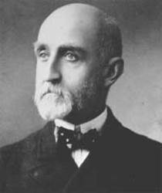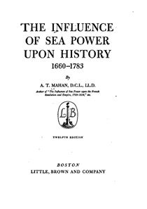

Alfred Thayer Mahan

Alfred Thayer Mahan was born in 1840 in New York. His father taught at the U.S. Military Academy at West Point, but Mahan graduated from the U.S. Naval Academy in 1859. He served in the Union navy during the Civil War, and afterward, he twice served as president of the Naval War College in Newport, Rhode Island. Mahan wrote a series of articles, with titles such as “The Future in Relation to American Naval Power,” and “Preparedness for Naval War.” Mahan thought of himself, first and foremost, as an historian. One of his earliest insights in preparing for his role at the Naval War College was that the course of the Second Punic War would have been changed irrevocably if Hannibal had access to the sea power that the Romans possessed.
* * *
“While distances have shortened, they remain for us water distances … for political influence they must be traversed in the last resort by a navy, the indispensable instrument by which, when emergencies arise, the nation can project is power beyond its own shore-line.”

“This isolation will pass away, and with it the indifference of foreign nations. From wheresoever they come and whithersoever they afterward go, all ships that use the canal will pass through the Caribbean.”
~ “The Isthmus and Sea Power.”

Hawaii possesses one of the best situations in the entire Pacific, “equidistant from San Francisco, Samoa, and the Marquesas, and an important post on our lines of communication with both Australia and China.”
~ From the article “Hawaii and Our Future Sea Power,” March 1893.

“The history of sea power is largely a narrative of contests between nations, of mutual rivalries, of violence frequently culminating in war. The profound influence of sea commerce upon the wealth and strength of countries was clearly seen long before the true principles which governed its growth and prosperity were detected. To secure to one's own people a disproportionate share of such benefits, every effort was made to exclude others, either by the peaceful legislative methods of monopoly or prohibitory regulations, or, when these failed, by direct violence. The clash of interests . . . led to wars. On the other hand, wars arising from other causes have been greatly modified in their conduct and issue by the control of the sea. Therefore the history of sea power, while embracing in its broad sweep all that tends to make a people great upon the sea or by the sea, is largely a military history...”
~ The Influence Of Sea Power Upon History, 1660 - 1783

Questions: (1) what “isthmus” is Mahan talking about?
(2) Is USA more like a continent (Europe, Asia) or an island (Great Britain)?

